**COMP90007 Internet Technologies**

**Project 1 – Network Analysis**

**Handan Yu**

**HANDANY**

**1235484**

**Section 2**

**Ans 2.1**

**Meaning of parameters:**

* n: Prints hop addresses numerically rather than symbolically and numerically. This flag saves a name-server address-to-name lookup for each gateway found on the path.
* w: Sets the time(in seconds) to wait for a response to a probe
* 1: the time to wait for a response to a probe is 1 seconds

**Importance of parameters:**

* n: Using IP can increase the speed of implementation, since it can reduce the time of host name resolution.
* w 1: Save test time

**Ans 2.2**

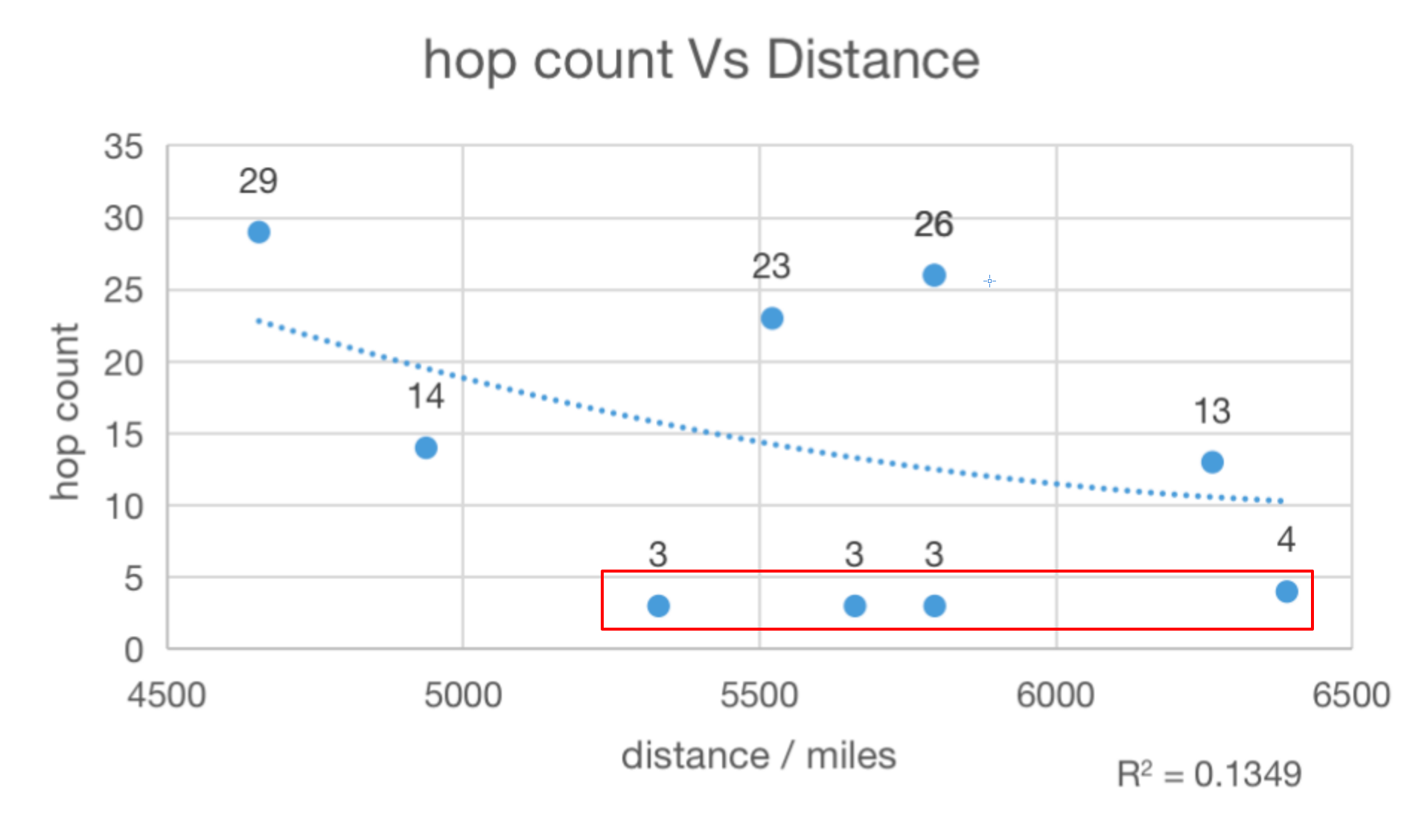

Fig. 2.2.1

According to Fig. 2.2.1, there is no an obvious correlation between hop count and distance, though from this figure, it seems that the number of hop decreases due to increasing distance. Since, the sample points I circled with red box might be outliers, in other words, it is time out or failure to detect these four hosts using ‘traceroute’ . Except these four hosts, these is also no exactly correlation between them. The main reason of such scenario I can think about is that there are several kinds of routing algorithm and each of them has different effects on network and router resources, and therefore sometimes the best route will change according to different situations like collisions.

**Section 3**

**Ans 3.1**

Looking at Fig <3.1.1>, <3.1.2>, and the experiment results and calculated results achieved in section 3 of the appendix A.

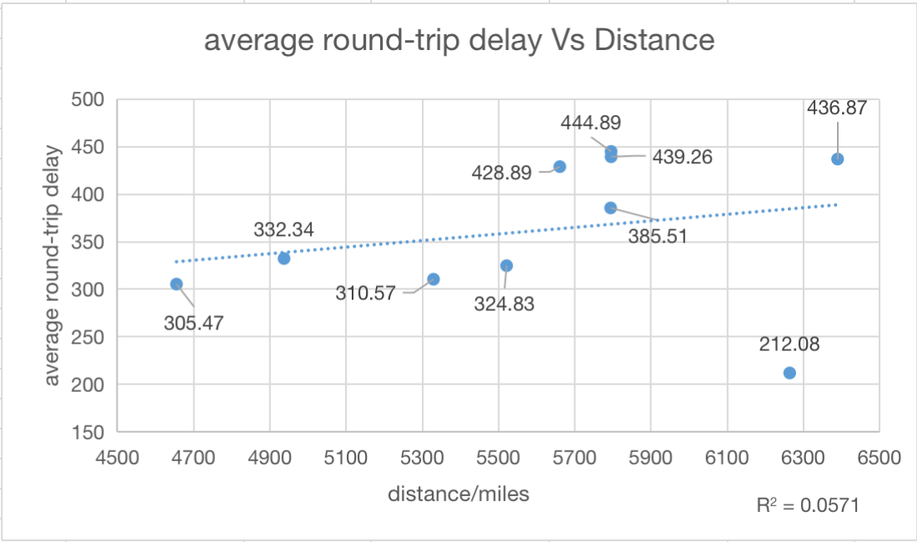

Fig. 3.1.2

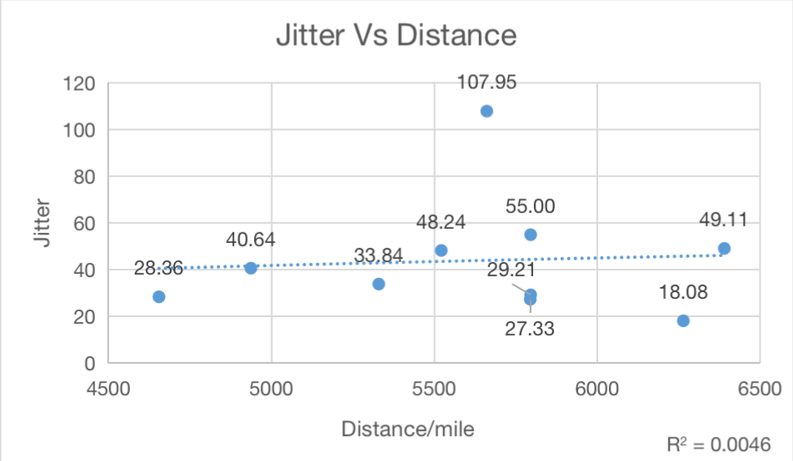

Fig. 3.1.3

Firstly, I recorded all of results including average delay and standard deviation of each round-trip using command ‘ping’ from my experiments and then computed the delay and jitter by averaging round-trip delays and standard deviations of three experiments.

After drawing the relationships between average round-trip delay and physical geographical distance, and between round-trip jitter and physical geographical distance respectively, it is hard to find a clear and exact correlations among them.

**Ans 3.2** Looking at Fig <3.2.1> and the result achieved in section 3 of the appendix A.

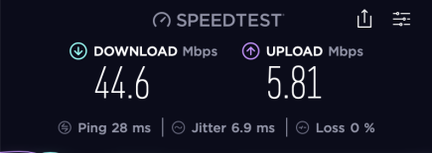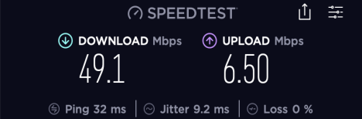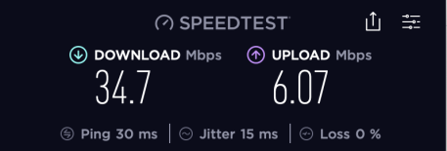

Fig. 3. 2.1

I test my network environment using application **Speedtest** three times, and then average these results I can get my network environment shown in following table.

|  |  |
| --- | --- |
| The download speed | 42.80 Mbps |
| The upload speed | 6.127 Mbps |

Also, in this experience the number of people sharing my network is 2.

The main networking environment that influence my results obtained might be my network occupancy and network bandwidth. To be concrete, when the available network occupancy is less (i.e., network usage is too high), it easily lead to delay. Also, when the network bandwidth is insufficient, it will still cause delay. In other words, there are multiple application need to transmit data at the same time, whereas the maximum of bandwidth is limited, so that it will cause a large amount of data loss and which will behave as a delay.

**Section 4**

**Ans 4.1** Looking at Fig <insert number> and the result achieved in section 4 of the appendix A.

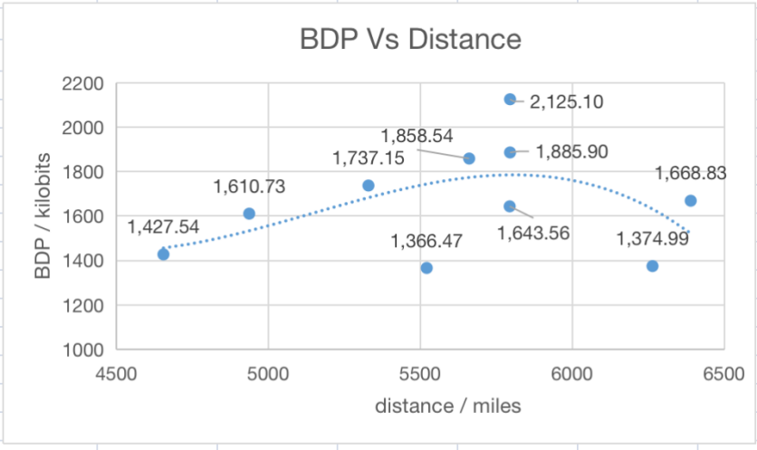<The bandwidth-delay product refers to the product of a data link's capacity and its end-to-end delay. The bandwidth then refers to the link speed and the delay refers to what the network would like to account for. Consequently, the bandwidth-delay product is the maximum number of bits that can be transmitted by the sender during a given time in the link.

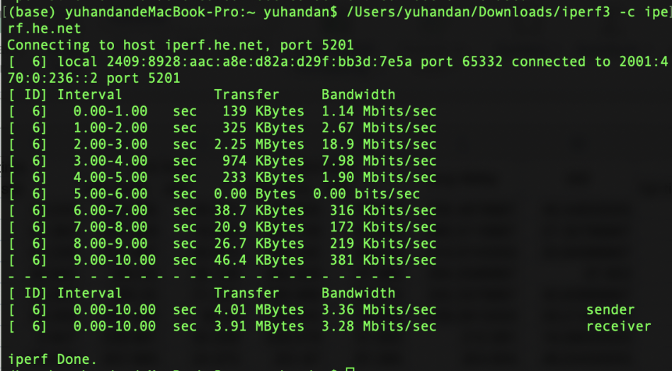

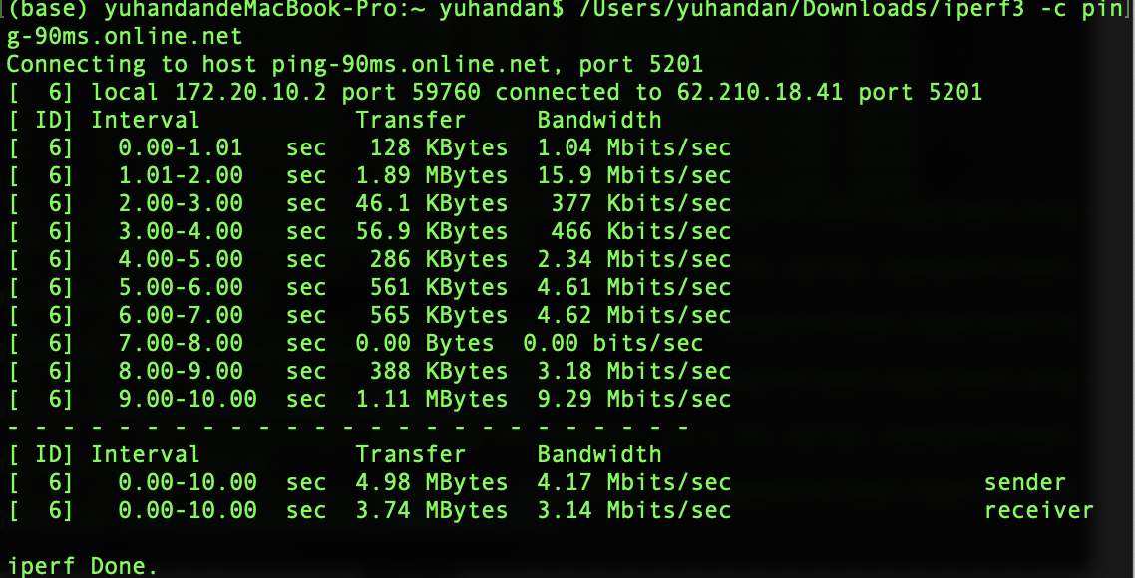

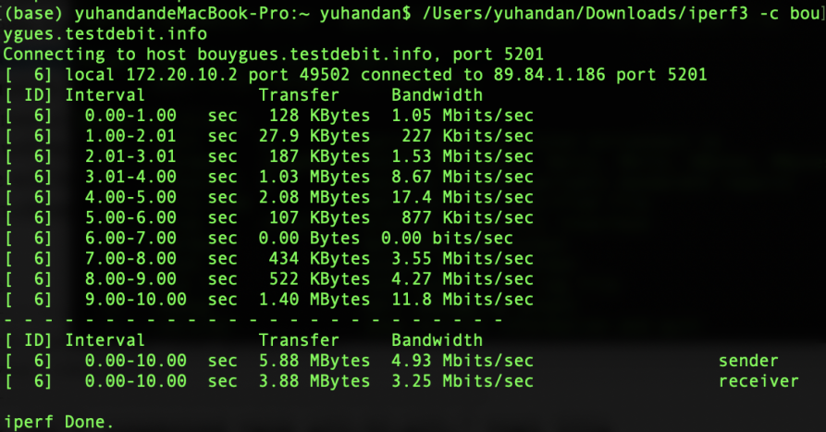

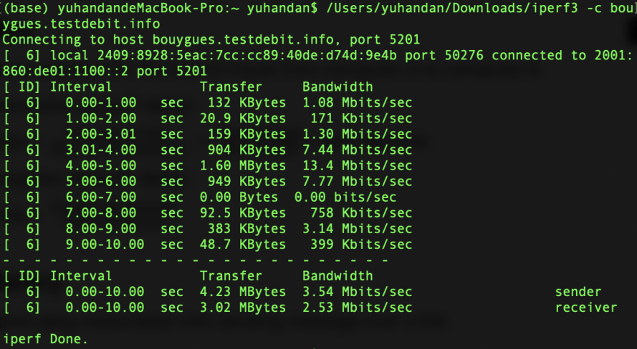

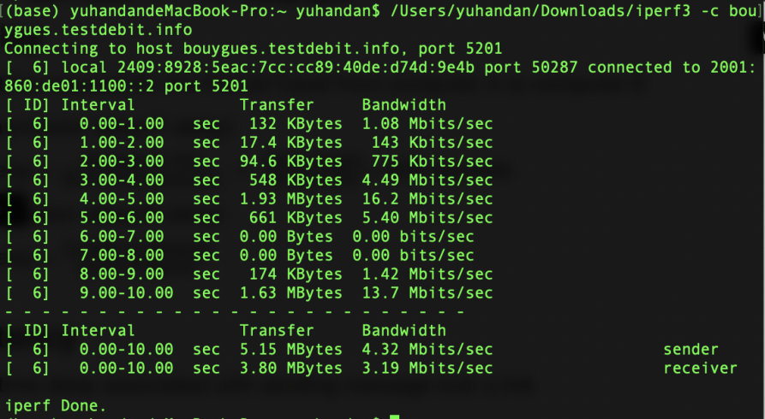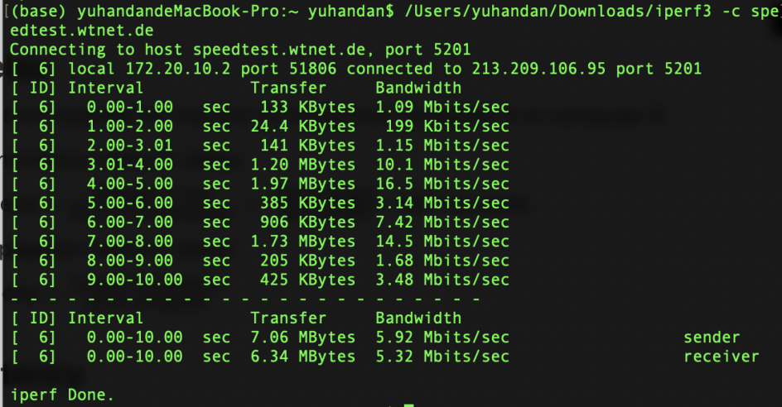

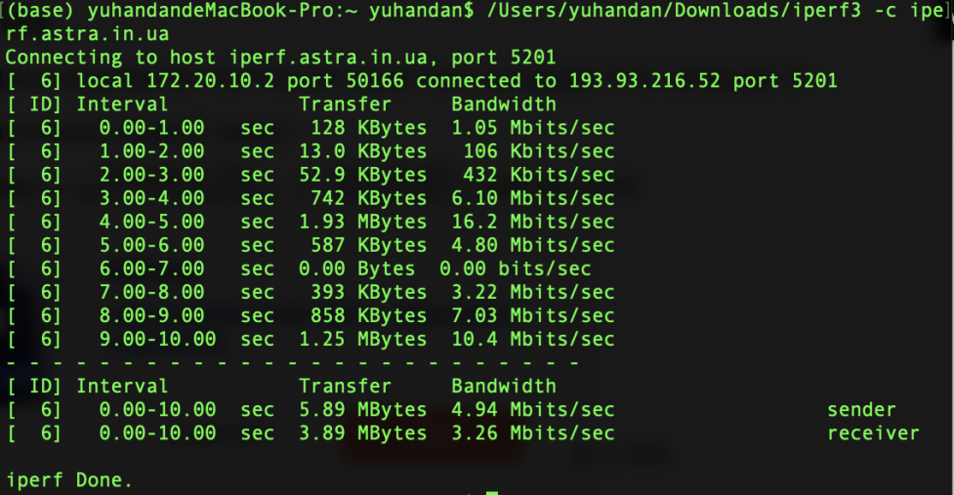

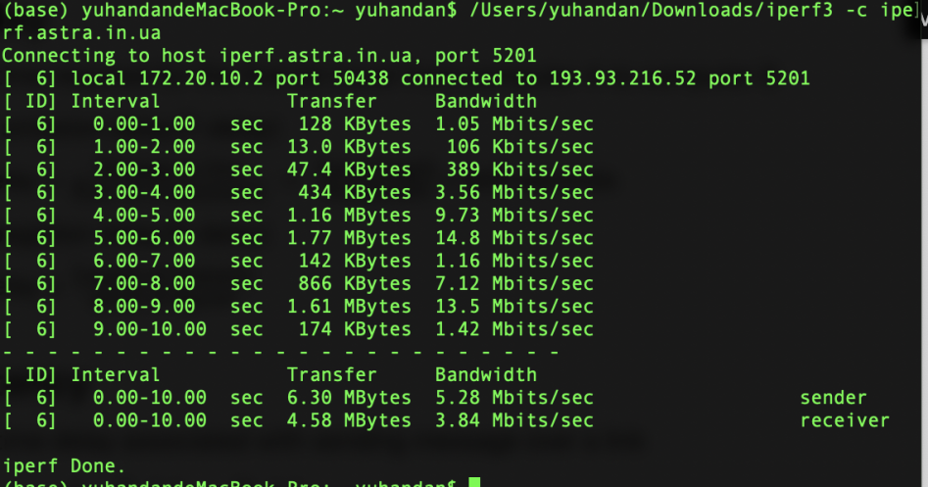

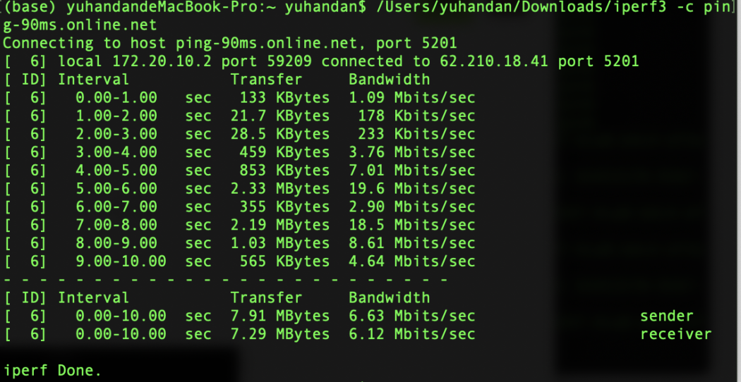

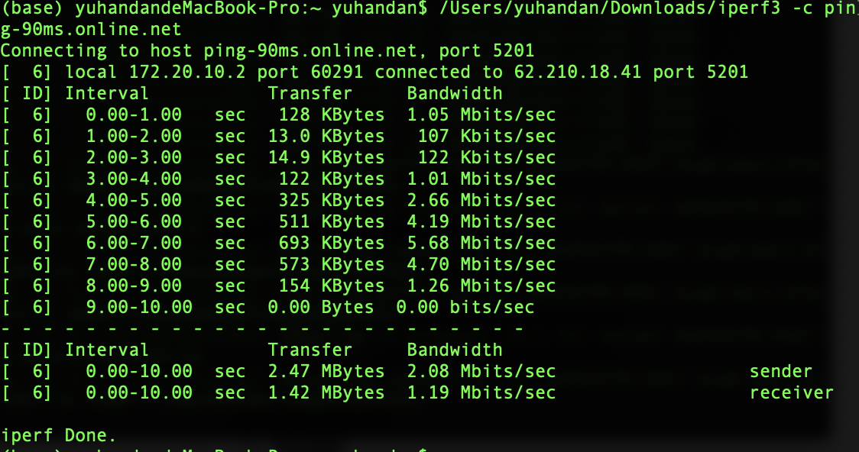

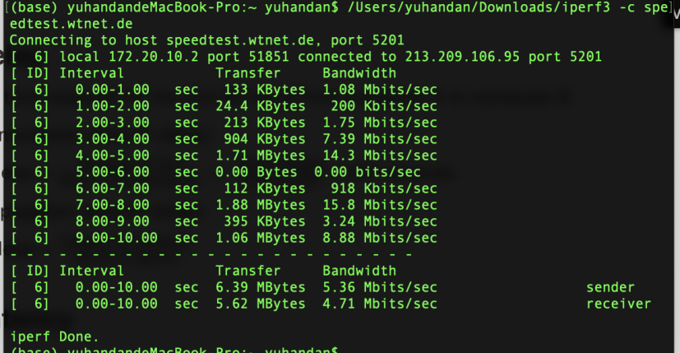

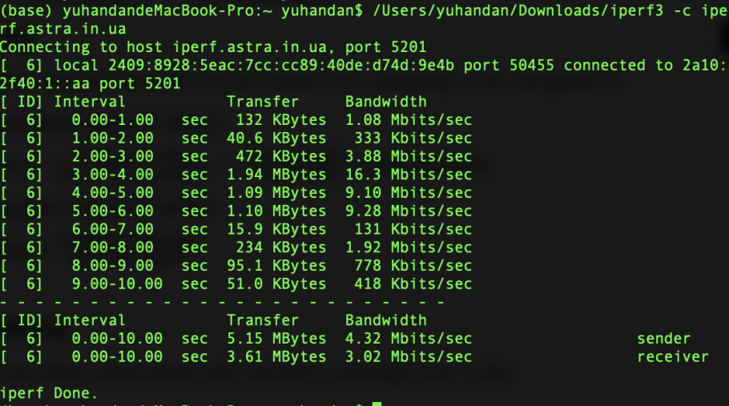

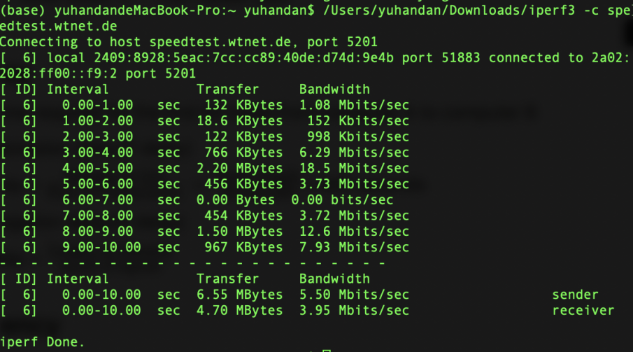

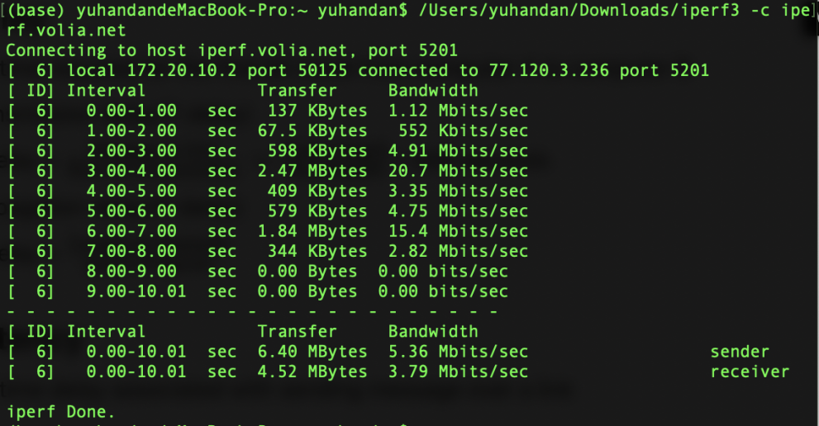

**Ans 4.2** Looking at Fig <insert number> and the result achieved in section 4 of the appendix....

<Place your figure Here>

Some more info about your analysis...

**Ans 4.3** Looking at Fig <insert number> and the result achieved in section 4 of the appendix....

<Place your figure Here>

Some more info about your analysis...

**Ans 4.4** Looking at Fig <insert number> and the result achieved in section 4 of the appendix....

<Place your figure Here>

Some more info about your analysis...

**Ans 4.5** Looking at Fig <insert number> and the result achieved in section 4 of the appendix....

<Place your figure Here>

Some more info about your analysis...

**References**

Use a consistent referencing scheme: <https://library.unimelb.edu.au/recite>

**Appendix**

Section 2

<Insert Images of results – screenshots of terminal/cmd>

<Insert Calculations>

Section 3

<Insert Images of results – screenshots of terminal/cmd>

<Insert Calculations>

Section 4

<Insert Images of results – screenshots of terminal/cmd>

<Insert Calculations>

